Q1. What is RDBMS
A1. RDBMS stands for Relational Database Management Systems. It is a program that allows us to create, delete, and update a relational database. A Relational Database is a database system that stores and retrieves data in a tabular format organized in the form of rows and columns. Tables are related (joined) based on common fields. e. g Oracle, MySQL, SQLite, SQL Server, MongoDB
Q2. What is SQL
A2. SQL stands for Structure Query Language. It is a standard programming language of RDBMS. It includes database creation, deletion, fetching rows and modifying rows etc. All RDMS system like Oracle, MySQL, SQLite, SQL Server, MongoDB use SQL as standard database language.
Q3. Write SQL Commands
A3. There are 4 types of SQL commands:
- DDL – Data Definition Language (create, truncate, drop, alter)
- DML – Data Manipulation Language (insert, update, delete)
- DCL – Data Control Language (grant, revoke)
- DQL – Data Query Language (select)
Q4. What is join?
A4. SQL Join statement is used to combine data or rows from two or more tables based on a common field between them. Different types of Joins are as follows:
- INNER JOIN
- LEFT JOIN
- RIGHT JOIN
- FULL JOIN
Q5. Write type of joins.
A5. Different types of Joins are as follows:
- INNER JOIN
- The INNER JOIN keyword selects all rows from both the tables as long as the condition is satisfied.
- This keyword will create the result-set by combining all rows from both the tables where the condition satisfies i.e value of the common field will be the same.
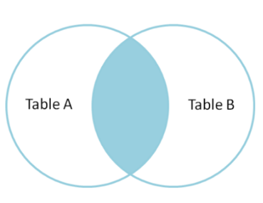

- LEFT JOIN
- This join returns all the rows of the table on the left side of the join and matches rows for the table on the right side of the join. For the rows for which there is no matching row on the right side, the result-set will contain null. LEFT JOIN is also known as LEFT OUTER JOIN.
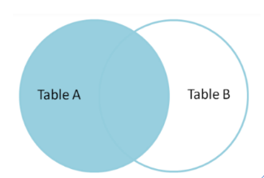
- RIGHT JOIN
- RIGHT JOIN is similar to LEFT JOIN. This join returns all the rows of the table on the right side of the join and matching rows for the table on the left side of the join. For the rows for which there is no matching row on the left side, the result-set will contain null. RIGHT JOIN is also known as RIGHT OUTER JOIN.
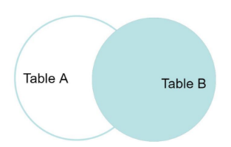
- FULL JOIN
- FULL JOIN creates the result-set by combining results of both LEFT JOIN and RIGHT JOIN. The result-set will contain all the rows from both tables. For the rows for which there is no matching, the result-set will contain NULL values.
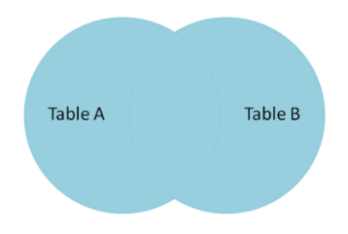

Q6. How many constraints and describes it self
A6. SQL constraints are used to specify rules for the data in a table. Constraints are used to limit the type of data that can go into a table. This ensures the accuracy and reliability of the data in the table. If there is any violation between the constraint and the data action, the action is aborted. Constraints can be column level or table level. Column level constraints apply to a column, and table level constraints apply to the whole table.
The following constraints are commonly used in SQL:
- SQL NOT NULL Constraint: By default, a column can hold NULL values. The NOT NULL constraint enforces a column to NOT accept NULL values. This enforces a field to always contain a value, which means that you cannot insert a new record, or update a record without adding a value to this field.
- SQL UNIQUE Constraint: The UNIQUE constraint ensures that all values in a column are different.
- SQL PRIMARY KEY Constraint: The PRIMARY KEY constraint uniquely identifies each record in a table. Primary keys must contain UNIQUE values, and cannot contain NULL values. A table can have only ONE primary key; and in the table, this primary key can consist of single or multiple columns (fields).
- SQL FOREIGN KEY Constraint: The FOREIGN KEY constraint is used to prevent actions that would destroy links between tables. A FOREIGN KEY is a field (or collection of fields) in one table, that refers to the PRIMARY KEY in another table. The table with the foreign key is called the child table, and the table with the primary key is called the referenced or parent table.
- SQL CHECK Constraint: The CHECK constraint is used to limit the value range that can be placed in a column. If you define a CHECK constraint on a column it will allow only certain values for this column. If you define a CHECK constraint on a table it can limit the values in certain columns based on values in other columns in the row.
- SQL DEFAULT Constraint: The DEFAULT constraint is used to set a default value for a column. The default value will be added to all new records, if no other value is specified.

Q7. Difference between RDBMS vs DBMS
A7.
Sr No | RDMS | DBMS
1 | Data stored is in table format | Data stored is in the file format
2 | Multiple data elements are accessible together | Individual access of data elements
3 | Data in the form of a table are linked together | No connection between data
4 | Support distributed database | No support for distributed database
5 | Data is stored in a large amount | Data stored is a small quantity
6 | RDBMS supports multiple users
7 | The software and hardware requirements are higher | The software and hardware requirements are low
8 | Example: Oracle, SQL Server. | Example: XML, Microsoft Access.

Q8. What is an SQL alias?
A8. SQL aliases are used to give a table, or a column in a table, a temporary name. Aliases are often used to make column names more readable. An alias only exists for the duration of that query. An alias is created with the AS keyword.

Q9. Write a query to create the table in Structured Query Language.
A9. Syntax to create the table in SQL is as follows:
CREATE table table_name
(
Column1 datatype (size),
column2 datatype (size),
.
.
columnN datatype(size)
);
e.g Student_tab
RollNo | FirstName | LastName | Percentage | Grade

CREATE table Student_tab
(
RollNo int,
FirstName varchar(255),
LastName varchar(255),
Percentage float(2),
Grade text
);
Q10. Write a query to insert data into table.
A10. Syntax to insert data into table in SQL is as follows:
INSERT INTO table_name (column1, column2, column3, ...)
VALUES (value1, value2, value3, ...);
e.g Student_tab
RollNo | FirstName | LastName | Percentage | Grade

INSERT INTO table Student_tab(RollNo,FirstName,LastName,Grade,Remarks) VALUES(1,’Priya’,’Patel’,87.89,’A’)
INSERT INTO table Student_tab(RollNo,FirstName,LastName,Grade,Remarks) VALUES(2,’Akashkumar’,’Mehta’,67.45,’B’)
INSERT INTO table Student_tab(RollNo,FirstName,LastName,Grade,Remarks) VALUES(3,’Rima’,’Shah’,55.00,’C’)
Q11. Write a query to update data into table with validations.
A11. Syntax to update data into table in SQL is as follows:
UPDATE table_name SET column1 = value1, column2 = value2,…
WHERE condition;
e.g Student_tab
RollNo | FirstName | LastName | Percentage | Grade
1 | Priya | Patel | 87.89 | A
2 | Akashkumar | Mehta | 67.45 | B
3 | Rima | Shah | 55.00 | C

UPDATE Student_tab SET FirstName = ‘Reema’ where RollNo = 3
Q12. Write a query to delete data from table with validations.
A12. Syntax to delete data from table in SQL is as follows:
DELETE FROM table_name WHERE condition;
e.g Student_tab
RollNo | FirstName | LastName | Percentage | Grade
1 | Priya | Patel | 87.89 | A
2 | Akashkumar | Mehta | 67.45 | B
3 | Rima | Shah | 55.00 | C

DELETE FROM Student_tab WHERE RollNo = 2
Q13. Write a query to insert new column in existing table.
A13. Syntax to insert new column in existing table in SQL is as follows:
ALTER TABLE table_name
ADD column_name datatype;
e.g Student_tab
RollNo | FirstName | LastName | Percentage | Grade
1 | Priya | Patel | 87.89 | A
3 | Rima | Shah | 55.00 | C

ALTER TABLE Student_tab ADD Remarks text;
Q14. Write a query to drop table and database.
A14. Syntax to drop table in SQL is as follows:
DROP TABLE table_name;
e.g Student_tab_1
RollNo | FirstName | LastName | Percentage | Grade | Remarks
1 | Priya | Patel | 87.89 | A
3 | Rima | Shah | 55.00 | C

DROP TABLE Student_tab_1
Q15. Write a query to find max and min value from table.
A15. Syntax to find max value from table in SQL is as follows:
SELECT MAX(column_name)
FROM table_name;
e.g Student_tab_2
RollNo | FirstName | LastName | Percentage | Grade | Remarks
1 | Priya | Patel | 87.89 | A | Excellent!
2 | Akashkumar | Mehta | 67.45 | B | Can do better.
3 | Rima | Shah | 55.00 | C | Need to improve.
5 | Divyang | Thakker | 70.30 | B | Can do better.
6 | Anjali | Patel | 96.99 | A | Excellent Performance. Keep it up!

SELECT MAX(Percentage) FROM Student_tab_2;
Syntax to find min value from table in SQL is as follows:
SELECT MIN(column_name)
FROM table_name;
SELECT MIN(Percentage) FROM Student_tab_2;
Q16. Create two tables named Seller and Product apply foreign key in product table Fetch data from both table using different joins.
A16.
Create Seller Table:
CREATE TABLE seller_tab
(
sid int PRIMARY KEY,
sname text,
avg_rating int
);
Insert Values into Seller Table:
INSERT INTO seller_tab VALUES (1,'Clicktech Services',4),
(2,'OnlineETrade',3),(3,'CoffeeBlue',5);
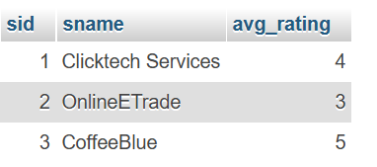
Create Product Table:
CREATE TABLE Product_tab
(
pid int,
pname text,
cost int,
sid int,

PRIMARY KEY(pid),
FOREIGN KEY(sid) REFERENCES seller_tab(sid)
);
Insert values into Product Table:
INSERT INTO product_tab VALUES
(1,'Boat Earphones',297,1),
(2,'JBL Earphones',599,1),
(3,'ADISA Laptop Bag',399,1),
(4,'Ezee Garbage Bags',169,2),
(5,'HIT Mosquito Racket',479,2),
(6,'Book - The Psychology of Money',285,3);
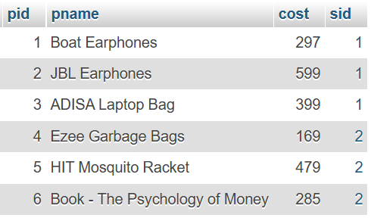

Use Inner Join:
select product_tab.pid, product_tab.pname, seller_tab.sname from product_tab INNER JOIN seller_tab on product_tab.sid=seller_tab.sid;
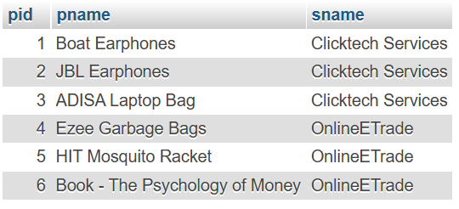
Use Left Outer Join:
select seller_tab.sname, product_tab.pname from seller_tab LEFT OUTER JOIN product_tab on product_tab.sid = seller_tab.sid;
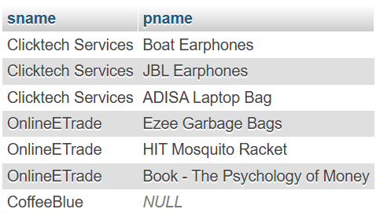
Use Right Outer Join:
select seller_tab.sname, product_tab.pname from seller_tab RIGHT OUTER JOIN product_tab on product_tab.sid = seller_tab.sid;
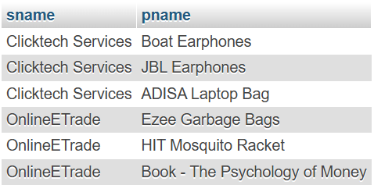
Use Full Join (not supported in XAMPP):
select seller_tab.sname, product_tab.pid from seller_tab FULL JOIN product_tab on product_tab.sid=seller_tab.sid;

Q17. What is API Testing
A17. API is the mediator which helps to applications to communicate with each other. It is kind of logic written by developers using any programming language to perform something. Testing the business logic of any application is called API. QA will test the same logic and called API testing. API testing is a part of back-end testing like database. API is a Software Interface that allows two applications to interact with each other without any user intervention. The purpose of API Testing is to check the functionality, reliability, performance, and security of the programming interfaces.
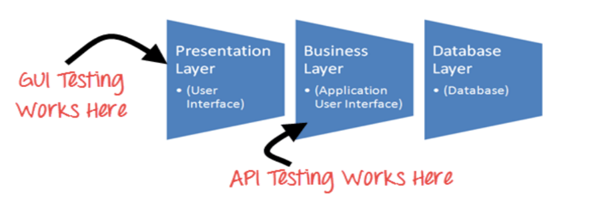
Q18. Types of API Testing
A18. Mainly 3 types of API Testing are as follows:
- Open APIs: These types of APIs are publicly available to use like OAuth APIs from Google. It has also not given any restriction to use them. So, they are also known as Public APIs.
- Partner APIs: Specific rights or licenses to access this type of API because they are not available to the public.
- Internal APIs: Internal or private. These APIs are developed by companies to use in their internal systems. It helps you to enhance the productivity of your teams.
Q19. What is Responsive Testing?
A19. Responsive testing involves how a website or web application looks and behaves on different devices, screen sizes, and resolutions. The goal of responsive testing is to ensure that the website or web application can be used effectively on various devices, including desktops, laptops, tablets, and smartphones.
Q20. Which types of tools are available for Responsive Testing
A20. Responsive testing tools are as follows:
- LT Browser
- Lembda Testing
- Google Resizer
- am I responsive
- Pixel tuner
Q21. What is the full form of .ipa, .apk
A21. .ipa – ios Package App
.apk – Android Application Package

Q22. How to create step for to open the developer option mode ON?
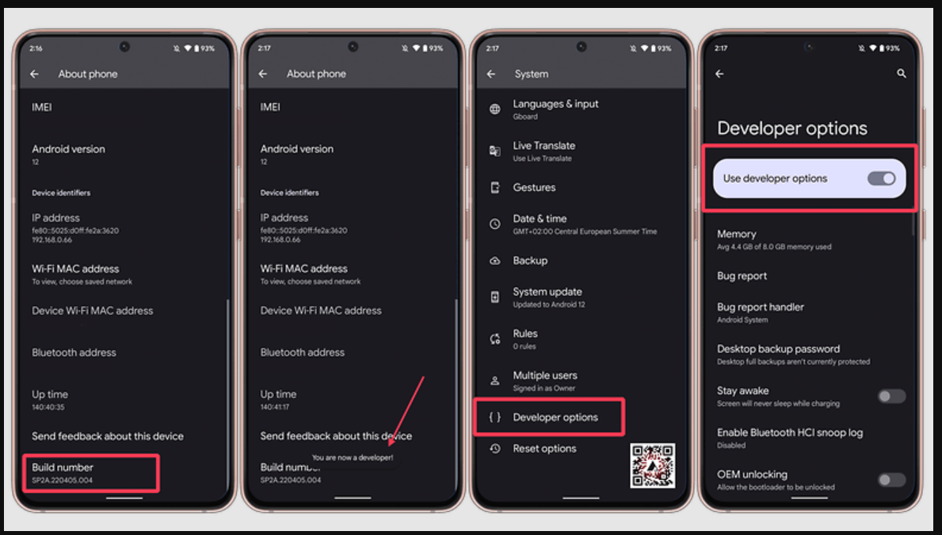
A22. Follow these steps to enable Developer Options on your Android device:
Step 1: Open the settings app on your Android phone.
Step 2: From the list of options find "About Phone" and click on it.
Step 3: In the About section find "Build number then click on it 7 times to enable developer option
Step 4: After the first few taps, you should see the steps counting down until you unlock the developer options. You may also have to tap in your PIN for verification.
Step 5: Once developer options are activated, you will see a message that reads, You are now a developer.
Step 6: Go back to the Settings pane, where you will now find Developer options as an entry.
Step 7: Tap it and toggle (USB debugging) the switch on if it is not already, and from there, you can proceed to make adjustments to your phone.

